|  |
| --- |
|  |
| **October Maple Hills PTA Newsletter**:  Back to School Edition |
|  |

**The Chirp!**

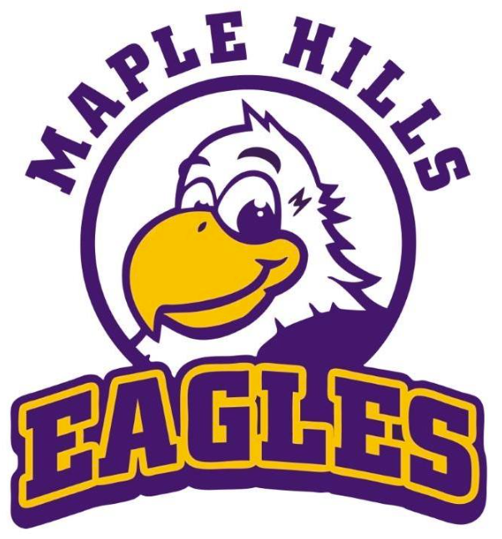

**Important Dates**

**October 4**Watch D.O.G.S – Donuts with Dads

**October 7**MH Library-Author Visit

**October 8**Popcorn Friday

**October 16**PTA General Membership Meeting

**October 18**  
NO SCHOOL - Teacher Workday

**October 24**  
Fall Glow Dance

|  |
| --- |
| Maple Hills PTA has achieved 100% for the last 24 years!   Let's keep it rolling!  We are currently at 51% |
| **PTA Membership Renewal**  **Must be renewed yearly to be a member**    **Becoming a member does not require you to be a volunteer-it’s an awesome perk!** |

**Connect With Us!**

Stay in the know with our weekly emails via our E-News. It includes important dates, events, and school programs, and more.

Email:   
[Communications@MapleHillsPTA.com](mailto:Communications@MapleHillsPTA.com)   
to get added to the mailing list!

|  |
| --- |
| Dear Maple Hills Families,  Welcome to a new and exciting school year!  As the PTA president, I am delighted to connect with all of you and look forward to a year filled with growth, learning, and fun.  Our school community thrives (and relies) on the collaboration between families, community, and school staff. We encourage your active participation in the PTA through events, programs, and volunteering. We have a year full of engaging and educational opportunities, classroom programs and fundraising.  Thank you for being an essential part of our school family and for your continued support and dedication to making our school a wonderful place for our children to learn and grow. Here’s to a fantastic year ahead!  Warm regards, Heather Stiles President, PTA  **2024-2025 PTA Volunteer Leadership Team:** Heather Stiles, Jorgan Peadon, Ricco Sanchez, Natalie Anderson, Sukhman Ghumman, Amanda Williams, Yaz Armstrong, Anne Krauser & Jennifer Cook |

It's time to show your Eagle pride, Maple Hills families! The ***Eagle Spirit Wear Shop*** is NOW OPEN!

Order your favorite spirit gear by **October 4th** and get ready to see your little Eagles sporting their new swag! All items will be delivered straight to your student's classroom.

Don’t miss out—fly on over to the shop today and grab your gear!

Scan the QR Code to Order Yours Today

|  |
| --- |
| Reflections Art Contest Calling all Maple Hills artists! This year’s Reflections contest theme is "Accepting Imperfection." Students are encouraged to express their creativity through visual art, dance, photography, literature, music, and more.    Schedule:   * Submission Deadline: November 1, 2024 * Judging: November 4th - 8th * Winners Announced: November 10th - 17th   We can't wait to see your creativity shine! ✨  For more information and entry form: https://maplehillspta.com/Page/Reflections/What%20is%20Reflections  Questions? E mail: reflectionsmaplehills@maplehillpta.com |

**Volunteers Make It Happen!**

If you would like to volunteer or have any questions, please email [volunteers@maplehillspta.com](mailto:volunteers@maplehillspta.com) or [onetimeevents@maplehillspta.com](mailto:onetimeevents@maplehillspta.com)  
To see more opportunities to help.

Volunteer Central:

|  |
| --- |
| **Support Families in Need: Gift Card Donation Drive** 💖 |
| **Help Us Make a Difference!** At Maple Hills Elementary, we are committed to supporting families in our community through the *McKinney-Vento* program. Many of these families are facing difficult times, and together, we can offer them a helping hand.  **How You Can Help** We are accepting **gift card donations** to assist families in need. Please consider donating in denominations of **$25**, **$50**, or **$100** for the following retailers:   * **Target** * **Fred Meyer** * **Safeway** * **Gas Credit Cards**   **Drop-Off Information** Please bring your gift card donations to the **school office** and include the **activation receipt** with your gift card.  **Why Your Donation Matters** Your donation directly helps families in need, providing essentials like food, clothing, and fuel. Let’s make a real impact together!  **Questions?** For more information or questions, please contact **Amber Bryant** at the school office.  Together, we can make a real impact in our community. Thank you for your kindness and generosity! 💙 |

**Volunteers Needed for Issaquah Schools Bond Measure!**

Help support our schools by volunteering for the upcoming bond measure. Your involvement can make a big difference in securing funding for crucial projects.

For more details and to get involved, visit <https://visvote.org/> or check out the   
Scan](https://maplehillspta.com/Page/PTA/VISScan) QR for VIS Site